RESIDENTIASL CASE STUDY
Purpose: Apply the knowledge of Chapter 4, Residential Energy Efficiency, in a design exercise

Directions: You are the designer. Using the 2009 IECC, answer the following questions.

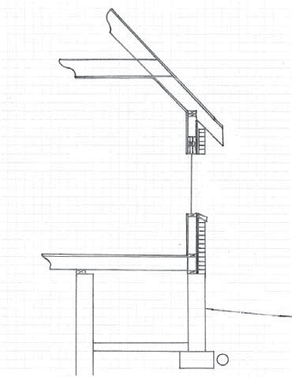
Scenario: An associate brought this rough sketch for your advice. The project involves a small, standard wood framed room addition onto an existing house.

Given:

• Climate Zone 6

• The addition will have a crawl space, cast in place concrete.
• The existing house has a basement, cast in place concrete.
• The walls are 2x6 with brick veneer.

• The floor joists, ceiling joists, and rafters are
2x10.

• The window is a fixed pane, wood frame.

• The ceiling/ roof configuration is not negotiable due to client wishes and zoning restraints.

Please comment and provide design options regarding:

- Compliance path and extent of compliance.
- Ceiling without attic space
- Ceiling with attic space.
- Walls.
- Windows.
- Crawl space.
- Basement.
- HVAC
- Lighting equipment
- Air leakage testing
- Duct leakage testing

